Gabriela Rivera

July 11, 2023

Guided Capstone Project Report

Big Mountain Resort in Montana hosts around 350,000 people throughout their winter season. In efforts to expand their accessible terrain, they have recently installed an additional chair lift. This project has increased their operating costs for the current season by $1.5M. They would like a data-driven strategy for accommodating this new expense through cost-cutting measures, charging a premium ticket price, and/or capitalizing on their current facilities. After some initial exploration of the dataset, we determined that the best course of action would be to create a pricing model based on the Adult Weekend ticket price, to determine the optimal price for tickets at Big Mountain Resort.

To ensure the dataset had sufficient information to answer the data science problem at hand, we combined a population dataset to see if population per capita had an effect on different resort’s ticket price. We wanted to determine what facility at our resort had the most positive impact on ticket price. The results of our linear regression model suggest that vertical drop is our biggest positive feature contributing to ticket price. This result is consistent with the predictions we made when initially exploring the dataset. Some other positive features we saw are: acres of snow making per year, total chairs, and number of fast quad chairs.

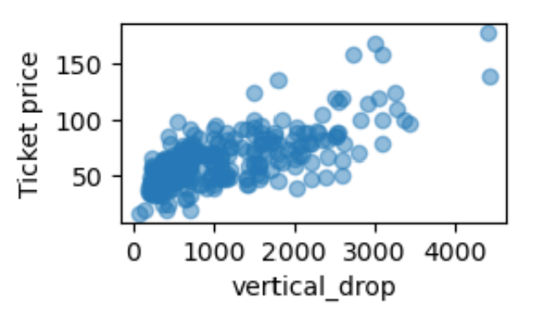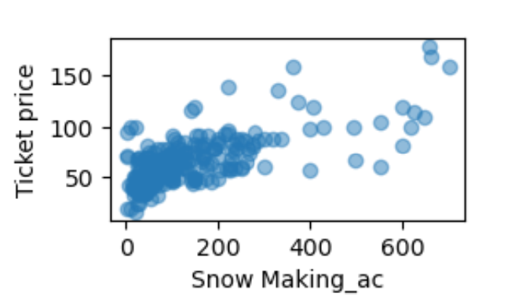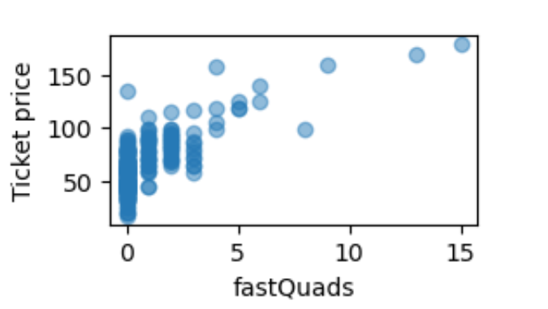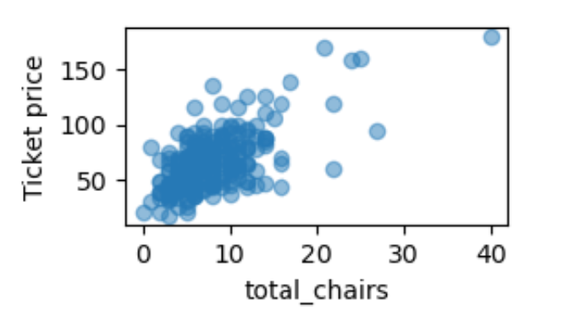

The figures above display the positive correlation between the four features and ticket price that we found during the exploratory data analysis process, that were later confirmed during our modeling stage. Below, you can see the feature importance output from our final forest regressor model.

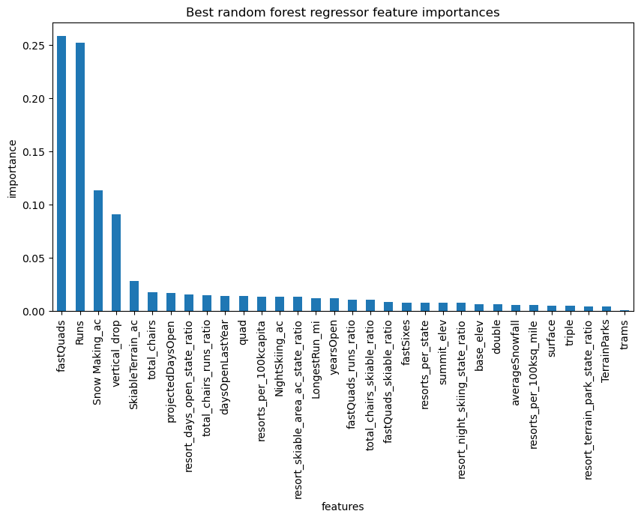

Big Mountain resort is currently charging $81 for their adult weekend ticket price. Our model suggests that Big Mountain can charge $95.87. With the expected mean absolute error of $10.39, this suggests that there is also room for an increase. The pricing model will enhance profitability by optimizing revenue streams and ensuring better resource allocation. I would also emphasize the competitive advantage that the updated pricing strategy can bring. For future improvements, I would suggest adding a run, increasing the vertical drop by 150 feet and installing an additional chair lift.